MD_MOSCOW_4C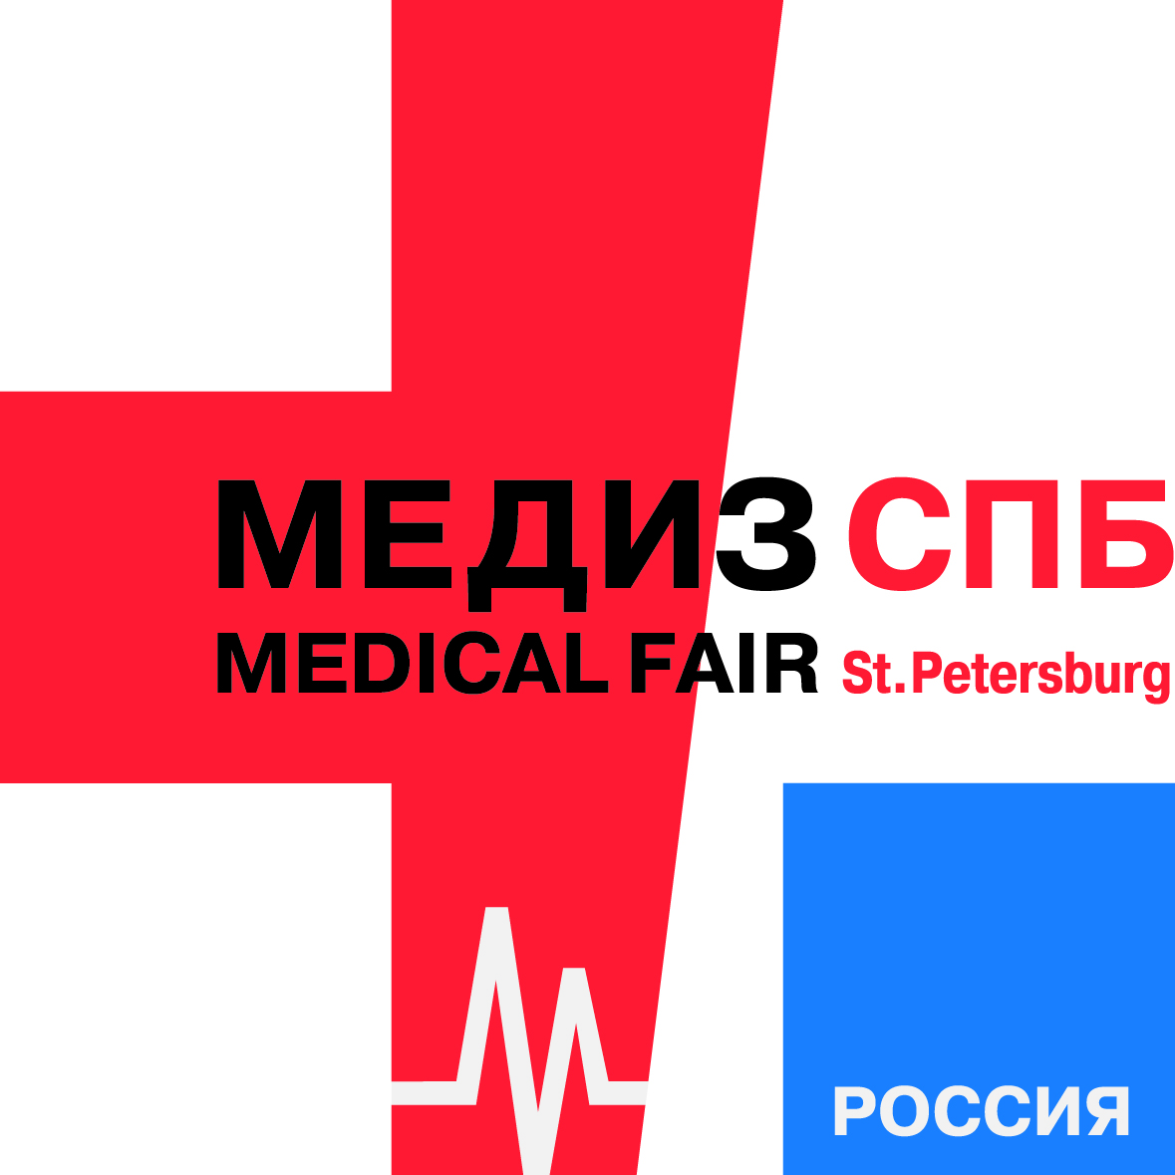

**Application for participation in MEDIZ SPB 2016**

**International Medical Fair and Congress**

|  |  |
| --- | --- |
| Messe Duesseldorf Moscow (further on MDM)  3, Bld.1 Timur Frunze str., Moscow, 119021,  TIN 7703335282, REC 770401001  S/a 40702978400010282053 with UniCredit Bank, JSC  9 Prechistenskaya Emb., Moscow, 119034  C/a 30101810300000000545, BIC 044525545 | Place of event: EXPOFORUM Fairgrounds, St Petersburg  Installation: **10 – 11 October 2016**  Time of event: **12 – 14 October 2016**  Dismantling: **14 October 2016 (from 16:00)**  **15 October 2015** |

[**www.mediz-spb.ru**](http://www.mediz-spb.ru)

|  |  |  |
| --- | --- | --- |
| **Exhibitor (participant)** |  | **Banking details** |
|  |  | **Settlement account** |
| **Co-exhibitors** |  | **Name of the bank** |
| **Company name** |  | **Correspondent Account** |
| **Post code / Country / City** | **Bank Identification Code** |
| **Legal address** |  | **Primary State Registration Number** |
| **Taxpayer Identification Number/** **Registration Event Code/** **Russian Business and Organization Classification Code** |  | **Chief's full name** |
| **E-mail** |  | **Accountant's full name** |
| **Telephone Fax** |  | **Contact person** |
|  |  |  |

**We order the following area on lease/servicing with Messe Duesseldorf Moscow LLC:**

|  |  |  |  |  |  |  |
| --- | --- | --- | --- | --- | --- | --- |
| Registration fee |  |  |  | 300.00 euro | = | euro |
| Unequipped space |  | sqm | х | 200.00 euro / sqm | = | euro |
| Equipped space |  | sqm | х | 250.00 euro / sqm | = | euro |
| Corner stand |  | sqm | х | 20.00 euro / sqm | = | euro |
| Stand open on 3 sides |  | sqm | х | 30.00 euro / sqm | = | euro |
| Stand open on 4 sides |  | sqm | х | 40.00 euro / sqm | = | euro |

Prices indicated without VAT!

The equipped space includes: installation and dismantling of the stand; carpet covering (gray); stand enclosure walls (height 250cm); white fascia panel with a company name, height 33 cm, one 70x70 cm table, four chairs; one archives cabinet; one coat rack; one wastepaper basket; one 150 W lamp per each 6 sqm of the stand area. To order extra services use separate fill-in forms of the operating manual. These services are charged extra.

|  |  |
| --- | --- |
| Total: | euro |
| VAT (18 %): | euro |
| Gross total: | euro |

This application is an offer on the part of the Exhibitor for concluding an agreement with MDM for participating in the exhibition. This application becomes an agreement after admission to participation in the exhibition according to the Terms of Participation in the Exhibition (signed on the part of MDM). By signing this Application the Exhibitor confirms that he has been familiarized with and agrees to the Terms of Participation in the Exhibition and the Safe Operation Rules (see the document "Service (list of extra services)"), placed on the MDM website at [www.messe-duesseldorf.ru](http://www.messe-duesseldorf.ru) . The said Terms, Rules and Annexes to the Application are binding for the Exhibitor and MDM. In case of divergence between the provisions of the Terms of Participation in the Exhibition and the Safe Operation Rules presented in a printed form (should these be available) and provisions of the said Terms and Rules placed on the MDM website at the above said address, the priority shall be given to the Terms and Rules placed on the MDM website. Fifty percent of the above mentioned gross total shall be paid by the Exhibitor to MDM within 2 weeks since the billing, while the balance of it shall be paid no later than 14 September 2016. In case of billing after 14 September 2016, the payment shall be made fully in a lump within 3 working days since the moment of billing. MDM shall start providing services only upon receipt from the Exhibitor of 100% of the said gross total. The payment shall be effected in euro.

|  |  |  |  |
| --- | --- | --- | --- |
|  |  |  | Messe Düsseldorf Moscow LLC |
| **Company name** |  |  | **Admission to participation**  Moscow |
| **Place and date** |  |  | **Place and date** |
| **Director-General / Director** |  |  | **Director-General**  (Thomas Stenzel) |

**Official stamp (signature) (clarification of signature) Official stamp**